Name Period Date

Practice 7-1, 7-2 and 7-3
Solving Systems of Linear Equations

Solve each system by graphing. Write no solution or infinitely many solutions where appropriate.
1. y = x + 3 2. y = x + 2
y = –2x + 3 –4x + y = –1
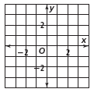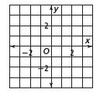

3. y – 4 = 2x 4. 2 + y = 2x
y – 2x = 4 y – 2x = 5
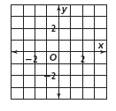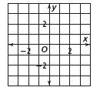

Solve each system using substitution. Write no solution or infinitely many solutions where appropriate.
5. x = –2y + 1 6. y = 5x + 5 7. y = x – 3
x = y – 5 y = 15x – 1 y = –3x + 25

8. 5x + 6y = –76 9. 3x – 2y = 10 10. –3x + 2y = –6
x + 2y = –44 y =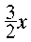–1 – 2x + y = 6

Solve by elimination. Show your work.
11. | –x + 8y = –32  3x – y = 27 | 12. | 2x + 7y = –7  5x + 7y = 14 | 13. | x + 6y = 48  –x + y = 8
14. | 2x + 8y = –42  –x + 8y = –63 | 15. | 5x + 9y = 112  3x – 2y = 8 | 16. | 6x + 3y = 27  –4x + 7y = 27
17. Shopping at Savers Mart, Lisa buys her children four shirts and three pairs of pants for $85.50. She returns
the next day and buys three shirts and five pairs of pants for $115.00. What is the price of each shirt and
each pair of pants?

18. Grandma’s Bakery sells single–crust apple pies for $6.99 and double–crust cherry pies for $10.99. The total
number of pies sold on a busy Friday was 36. If the amount collected for all the pies that day was $331.64,
how many of each type were sold?

19. At an ice cream parlor, ice cream cones cost $1.10 and sundaes cost $2.35. One day, the receipts for a total of
172 cones and sundaes were $294.20. How many cones were sold?

