Name Class Date
Practice 2-6 Theoretical and Experimental Probability
A driver collected data on how long it takes to drive to work.
Time in minutes | 20 | 25 | 30
Number of trips | 4 | 8 | 2
1. Find P(the trip will take 25 min).
2. Find P(the trip will take 20 min).
3. Find P(the trip will take at least 25 min).
Use the data in the line plot to find each probability.
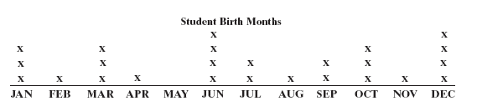
4. P(June) 5. P(October) 6. P(first six months of year)
7. P(May) 8. P(not December) 9. P(last three months of year)
A cereal manufacturer selects 100 boxes of cereal at random. Ninety-nine of the boxes are the correct weight. Find each probability.
10. P(the cereal box is the correct weight)
11. P(the cereal box is not the correct weight)
12. There are 24,000 boxes of cereal. Predict how many of the boxes are the correct weight.
13. One letter is chosen at random from the word ALGEBRA. Find each probability.
a. P(the letter is A) b. P(the letter is a vowel)
14. Patrice has a 40% chance of making a free throw. What is the probability that she will miss the free throw?
15. A box of animal crackers contains five hippos, two lions, three zebras, and four elephants. Find the probability if one animal cracker is chosen at random.
a. P(a hippo) b. P(not an elephant)
c. P(an elephant or a lion)
16. Anthony is making a collage for his art class by picking shapes randomly. He has five squares, two triangles, two ovals, and four circles. Find each probability.
a. P(circle is chosen first) b. P(a square is not chosen first)
c. P(a triangle or a square is chosen first)

