Name _____________________________________ Class _________ Date ________________

Practice 4-5 Isosceles and Equilateral Triangles

Find the values of the variables.
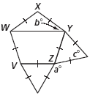
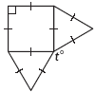
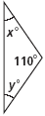
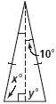
1. 2. 3.
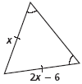
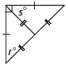
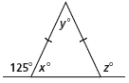
4. 5. 6. WXYZV is a regular polygon.
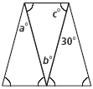
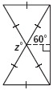
7. 8. 9.

Find the values of x and y.
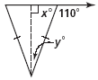
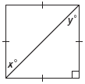
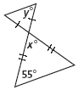
20. 21. 22.

